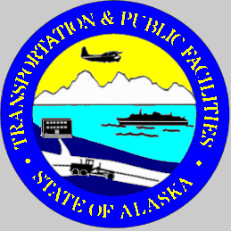 | Alaska Department of Transportation and Public Facilities  Construction General Permit  Noncompliance Notification  DEC Toll Free: 1(877) 569-4114 Fax: (907) 269-4604

GENERAL INFORMATION
DOT&PF Region: |  |  | Project Name: |  |  |  |  | Project Location:
DOT&PF CGP Tracking Number: |  |  | Contractor: |  |  |  |  | Contractor CGP Tracking Number:
Person Reporting: |  |  | Phone Numbers of Person Reporting: |  |  |  |  | Reported How? (e.g. by phone):
Date/Time Event was Noticed: |  |  | Date/Time Reported to DEC: |  |  |  |  | Name of DEC Staff Contacted:
VERBAL NOTIFICATION MUST BE MADE TO DEC WITHIN 24 HOURS OF DISCOVERY OF NONCOMPLIANCE
INCIDENT DETAILS (attach additional sheets, lab reports, and photos as necessary)
Period of Noncompliance
Start Date/Time (exact): |  |  |  |  |  | End Date/Time (exact):
If noncompliance has not been corrected, provide a statement regarding the anticipated time the noncompliance is expected to continue:

Description of the noncompliance and its cause (be specific):

Actions taken to reduce, eliminate, and prevent reoccurrence of noncompliance:

Pollutant:
Corrective Actions:

I certify under penalty of law that this document and all attachments were prepared under my direction or supervision in accordance with a system designed to assure that qualified personnel properly gather and evaluate the information submitted. Based on my inquiry of the person or persons who manage the system, or those persons directly responsible for gathering the information, the information submitted is, to the best of my knowledge and belief, true, accurate, and complete. I am aware that there are significant penalties for submitting false information, including the possibility of fine and imprisonment for knowing violations.
Name: |  | Title: |  |  | Signature: |  |  |  | Date:
FORM MUST BE SENT TO DEC WITHIN FIVE DAYS OF BECOMING AWARE OF THE EVENT.

